CS 255 System Design Document Template

This template lays out all the different sections that you need to complete for Project Two. Each section has guidance to prompt your thinking. You will need to continually reference the interview transcript as you work to make sure that you are addressing your client’s needs. There is no required length for the final document. Instead the goal is to complete each section based on what your client’s needs are. Remove this note when you are finished, and replace all bracketed text with the relevant information.

UML Diagrams

UML Use Case Diagram
Below is the DriverPass Use Case Diagram.
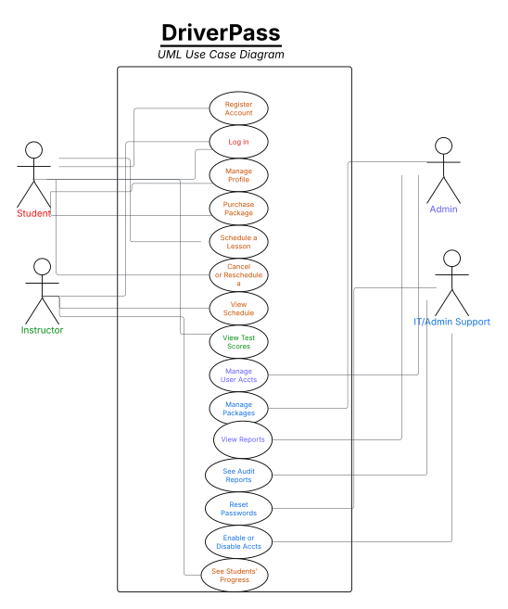
UML Activity Diagrams
Below is a UML Activity Diagram for “Access or Create Account”.
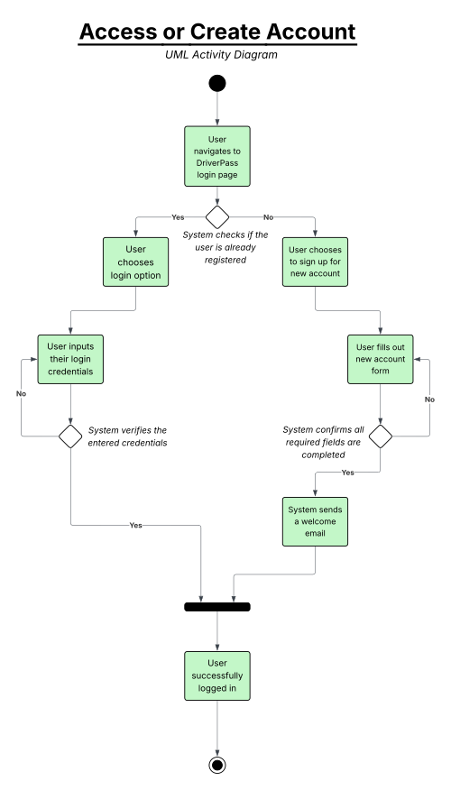

Below is a UML Activity Diagram for “Booking a Driving Lesson”.
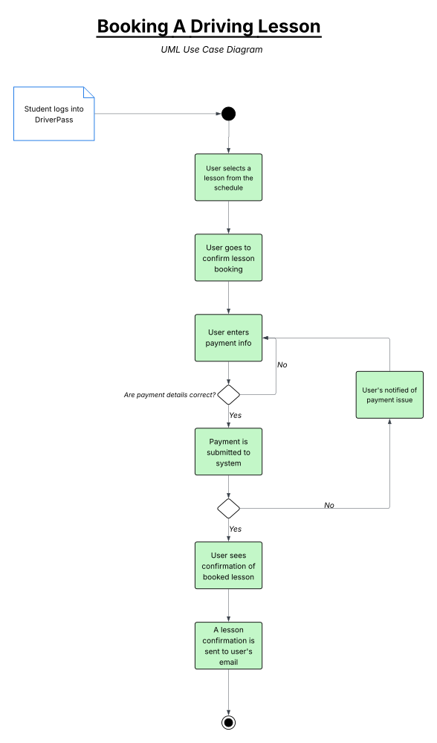
UML Sequence Diagram
Below is a UML Sequence Diagram for “Booking a Lesson”.

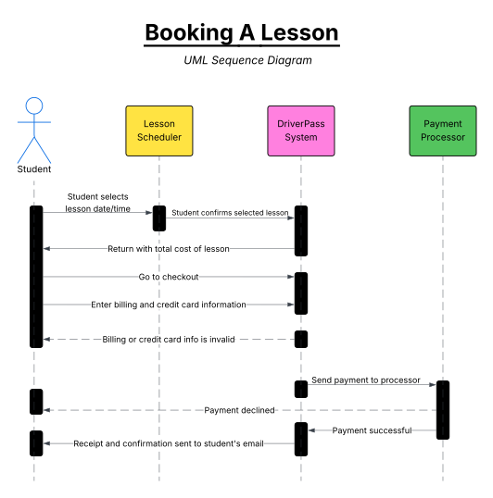

UML Class Diagram
Below is a UML Class Diagram for DriverPass.
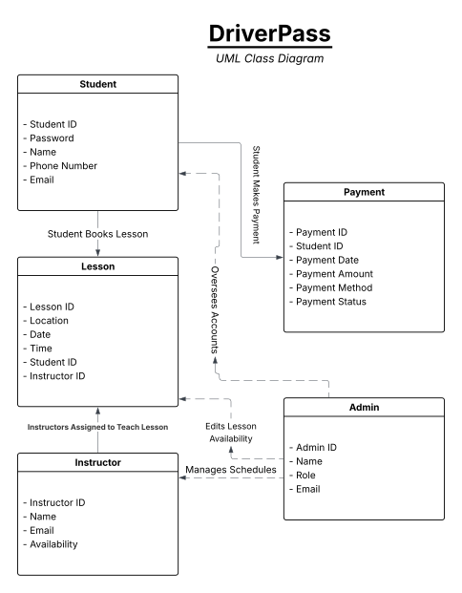

Technical Requirements

The technical requirements of this system include the following:

Hardware
- The DriverPass system will run on cloud-based servers so students and instructors can log in from mobile devices or desktop computers (no downloads required).
- Instructors and admins should be able to access the dashboard from any desktop browser in an office setting.
- The system needs enough storage to hold student accounts, practice tests, lesson schedules, and progress reports.

Software
- The website should work smoothly on all major browsers, like Chrome, Safari, Firefox, and Edge, as well as different operating systems, like Windows, Android, macOS, and iOS.
- A front-end framework such as React or Angular will help make the site mobile-friendly and user-friendly.
- A back-end database will store student info, lessons, payments, and login activity.
- A back-end application framework will handle account creation, lesson booking, and admin tools.
Tools
- LucidChart will be used to build and update system diagrams.
- GitHub will be used for version control and tracking updates to the project.
- PayPal will handle secure payment processing.
- An email service will send out booking confirmations, password resets, and other notifications.
Infrastructure
- All user data should be protected with HTTPS and strong encryption (TLS 1.3).
- Admins and instructors will need to use two-factor authentication when logging in.
- After five failed login attempts, accounts should lock and trigger a password reset process.
- The system should log important activity, like changes to schedules or user settings, for accountability.
- Admins should be able to adjust lesson duration, pickup zones, user roles, and other settings from their dashboard (no code changes required).
- Hosting should be done on a reliable cloud platform like AWS, Azure, or Google Cloud to support flexibility and growth.

